RAM ENTERPRISE P&P WBS STRUCTURE - 09_AI_Knowledge_HUB

09_AI_Knowledge_HUB
(Enterprise AI Governance, Enablement & Knowledge Management Framework for RAM)
This module establishes a structured AI governance, enablement, risk control, and knowledge architecture across all RAM functions (Governance, Investment, Leasing, FM, CapEx, Performance, Risk & Compliance, Master Data).

09.1 AI Governance & Oversight Policy
Purpose: Ensure responsible, ethical, secure, and business-aligned AI deployment.

09.1.1 AI Governance Charter
- Define AI vision aligned with corporate strategy
- Establish AI Steering Committee
- Define decision rights & accountability matrix
- AI investment approval workflow

09.1.2 AI Ethics & Responsible Use Policy
Aligned with:
- OECD AI Principles
- European Commission AI Act guidelines
- ISO 42001 (AI Management System)
Controls:
- Bias mitigation framework
- Human-in-the-loop requirements
- Transparency & explainability
- AI decision override protocol

09.2 AI Use Case Management

09.2.1 AI Use Case Intake Procedure
WBS Structure:
- 09.2.1.1 Business Need Identification Form (AI-F-001)
- 09.2.1.2 Value Assessment Template (ROI / Efficiency / Risk)
- 09.2.1.3 Data Availability Assessment
- 09.2.1.4 Risk Classification Matrix
- 09.2.1.5 Steering Committee Approval

09.2.2 AI Portfolio Categorization
- Operational AI (FM predictive maintenance)
- Financial AI (Investment analytics)
- Risk AI (Fraud detection)
- Customer AI (Tenant churn prediction)
- Knowledge AI (Policy assistant, chatbot)

09.3 AI Data Governance Integration
Aligned with 08_Master_Data

09.3.1 Data Quality Controls
- Data lineage mapping
- AI training data approval
- Periodic bias testing

09.3.2 Data Protection Compliance
Aligned with:
- General Data Protection Regulation
- Egypt PDPL (where applicable)
Controls:
- Anonymization standard
- Role-based access
- AI log retention policy

09.4 AI Risk & Compliance Framework
Integrated with 07_Risk_Compliance

09.4.1 AI Risk Taxonomy
- Model risk
- Data drift risk
- Hallucination risk
- Cybersecurity exposure
- Regulatory non-compliance

09.4.2 AI Risk Register Template
WBS-coded:
- 09.4.2.1 Risk ID
- 09.4.2.2 Risk Description
- 09.4.2.3 Likelihood
- 09.4.2.4 Impact
- 09.4.2.5 Mitigation
- 09.4.2.6 Control Owner
- 09.4.2.7 Monitoring Frequency
Framework alignment:
- COSO ERM
- ISO 31000 Risk

09.5 AI Knowledge Repository Architecture

09.5.1 AI Knowledge Layers
Layer | Description | Owner
L1 | Policies & Procedures | Governance
L2 | AI Models & Algorithms | IT/Data
L3 | Use Case Documentation | Business Units
L4 | Lessons Learned & Case Studies | PMO
L5 | Training & SOP Videos | HR

09.6 AI Training & Capability Development

09.6.1 AI Maturity Levels
Level | Description
Level 1 | Awareness
Level 2 | Assisted AI
Level 3 | Embedded AI
Level 4 | Predictive
Level 5 | Autonomous Governance AI

09.6.2 AI Certification Tracks
- Executive AI Literacy
- AI Risk & Compliance
- Data Stewardship
- AI Prompt Engineering

09.7 AI Technology Stack Architecture

09.7.1 Core AI Components

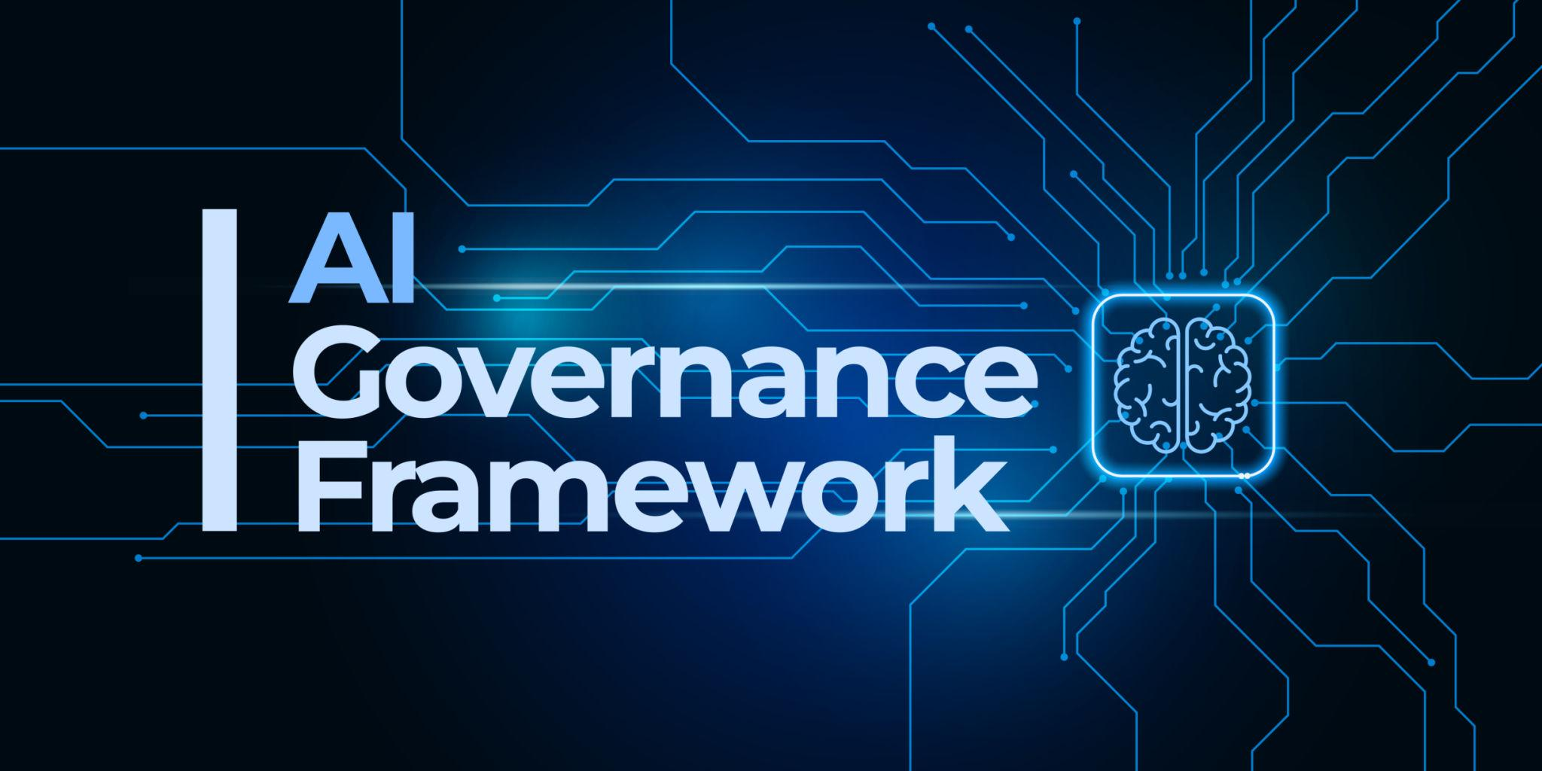
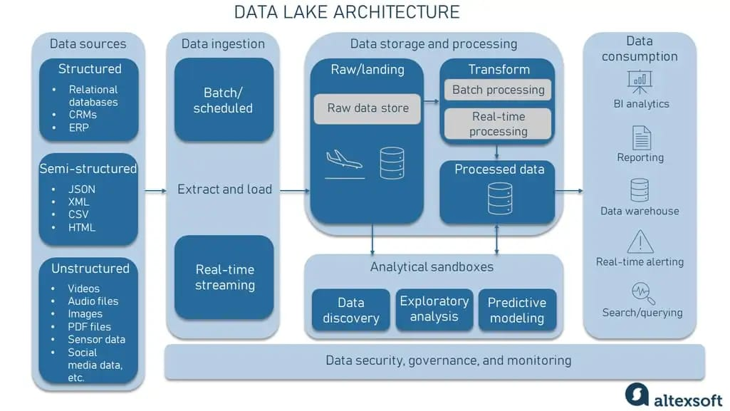
4
Layers:
- Data Layer (ERP, Leasing, FM Systems)
- Data Lake / Warehouse
- ML/AI Layer
- Governance & Monitoring
- User Interface (Dashboards / Chatbots)

09.8 AI KPI & Performance Monitoring

09.8.1 AI Value KPIs
KPI Category | Example
Financial | ROI per model
Operational | Process time reduction
Risk | False positive rate
Compliance | % of models audited
Adoption | Active AI users

09.8.2 AI Dashboard Structure
- Model performance tracking
- Drift detection
- Risk exposure heatmap
- Usage analytics

09.9 AI Forms & Templates Structure
Forms Tree Example:
- AI-F-001 Use Case Request
- AI-F-002 Data Assessment
- AI-F-003 Risk Classification
- AI-F-004 Model Approval
- AI-F-005 Post-Implementation Review
- AI-F-006 Incident Reporting
- AI-F-007 Bias Assessment

09.10 AI BPMN High-Level Flow
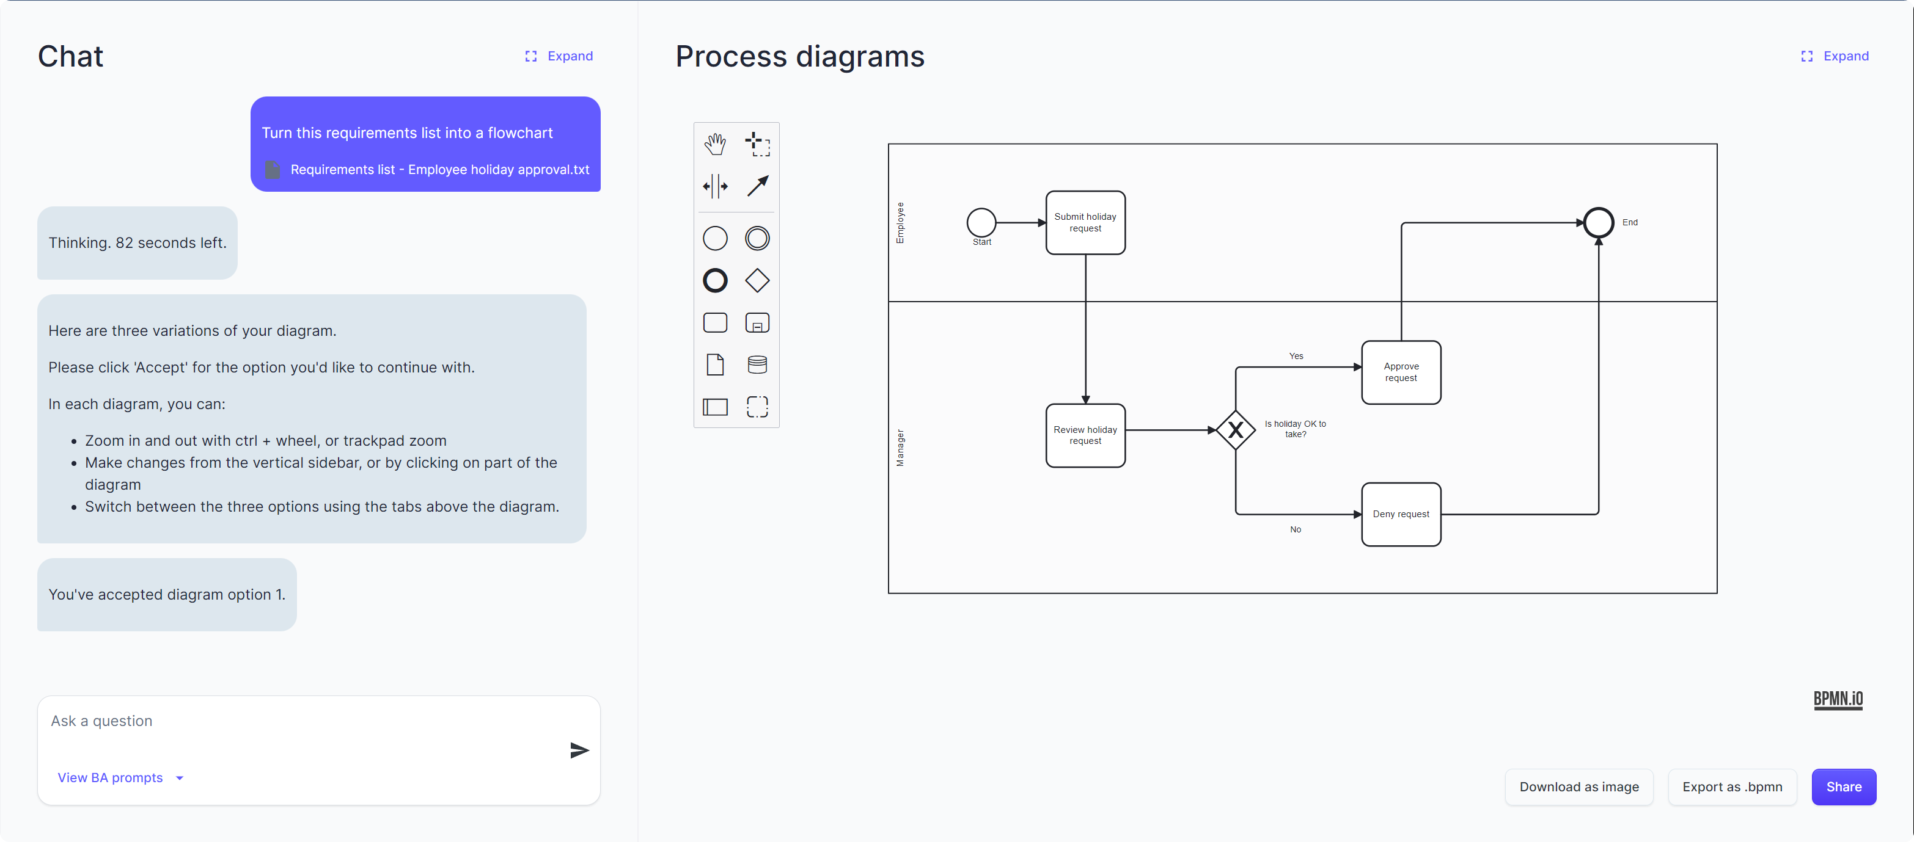
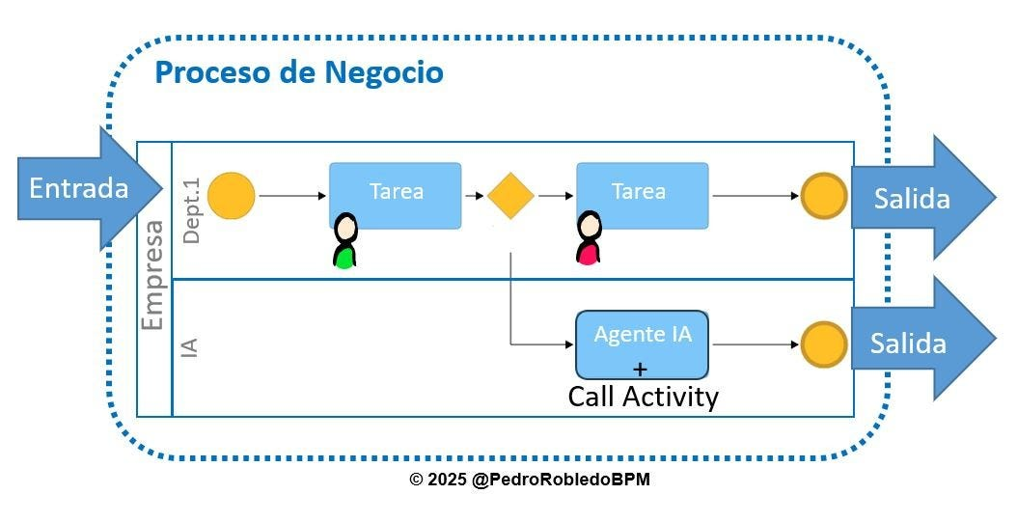
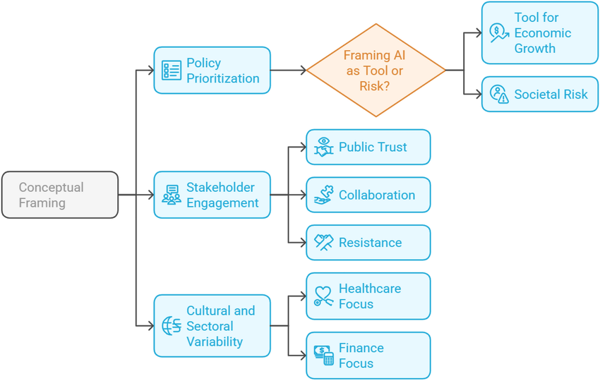
4
Lifecycle Flow:
Idea → Assessment → Approval → Development → Validation → Deployment → Monitoring → Audit → Continuous Improvement

09.11 AI Governance Risk & Control Matrix (Aligned with ISO 42001 & COSO)
Risk | Control | Control Type | Frequency | Owner
Biased output | Bias testing protocol | Preventive | Quarterly | Data Lead
Data leakage | Access controls | Preventive | Continuous | IT
Model drift | Performance monitoring | Detective | Monthly | AI Team
Unauthorized use | Role permissions | Preventive | Continuous | IT Security
Regulatory breach | Compliance review | Preventive | Semi-Annual | Compliance

Integration with Other RAM Modules
Module | AI Role
01_Governance | AI decision analytics
02_Investment | Predictive investment scoring
03_Leasing | Tenant risk modeling
04_Facility_Management | Predictive maintenance
05_CapEx_Projects | Cost overrun forecasting
06_Performance | KPI automation
07_Risk_Compliance | Risk analytics
08_Master_Data | AI data backbone

If you want next step, we can:
1️⃣ Convert this into full WBS-coded policy manual structure (09.1.1.1 format)
2️⃣ Build full AI Governance Risk & Control Matrix (detailed 30+ controls)
3️⃣ Design full AI Maturity Assessment Tool (scoring 1–5 structured table)
4️⃣ Create a Board-ready AI Strategy PPT (BETA-RESEARCH branding)
Tell me which direction we take next.

